MIDTOWNERS SUNSHINE OF THE WEEK ► January 4, 2008
No Sunshine Announcements.

SPEAKER OF THE WEEK ► Hem Pokharel & Hari Govinda Prajapati
THEME | Household Water Treatment Systems
Rtn. Hem and Mr. Hari Prajapati will demonstrate a water-filter making process that was developed by Solutions Benefiting Life (SBL), a non-profit organization based near Boston, USA. Its simplicity and its efficiency make the filtering process special. Since Nepal has a pool of great potters, with enough awareness and motivation, these filters can be produced locally. SBL sees a huge opportunity for local businessmen, jobs for local people, clean water for consumers, and clean environment for all (no plastic). All the steps of manufacturing are done by local manufacturers.
Rtn. Hem has been working for SBL for 4 years as a project manager. He has carried out research on the sustainable low-cost household water purification systems for developing countries. He also works with local potters and businessmen to establish micro-financed businesses in developing countries. Mr. Hari Prajapati has been working for SBL for more than 3 years as a project manager and producer of SBL units for Nepal. He has produced and sold more than 3000 SBL filter in last two years. He has more than two decades of experience in pottery and is also the founder of Madhyapur Clay Craft. He is also the president of Nepal Ceramic Society. He has been to India, Japan, Thailand and Bangladesh to train the local potter of that country. At present he is trainning 6 potters from Damauli, Dang, Nawalparasi, Kapilvastu, Nepalgunj and Chitwan at his facility. He studied modern ceramics and pottery from India, Thailand, Japan and Bangladesh.

UPCOMING SPEAKERS ► PREVIEW
DATE | SPEAKER | THEME
Jan 11th | Ms. Isabelle Pastor | Shechen Clinic – holistic clinic for local communities
Jan 18th | Dr. Saurav Dev Bhatta | Deadly sins of Statistical Misrepresentation in the Media
Jan 25th | Chandra Morgan | To be confirmed

THE MID-TOWN CLUB ► NEWS
2008-09 Board of Directors

President Elect RR Shrestha announced the Board for the Rotary Year 2008-09. They are as follows:
President | RR Shrestha
Vice President | Govind Chipalu
Secretary | Dr. Som Pudasaini
Treasurer | Dr. Roop Jyoti
Joint Secretary | Pramod Poudel
Immediate Past Presidnet | Walter Diller
President Elelct | Vacant
Director, Community Service | Pratap Malla
Director, International Service | Saroj Shrestha
Director, Vocational Service | Navyo Eller
Director, Club Service | Jo Logghe
Chair, ICM Committee | Komal Chitracar
Chair, Membership Development | CK Golchha

Congratulations to the New Board members!!!
Scenes from Last Week’s meeting
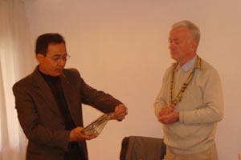  PP Mani handing 100 percent PHF Club Plaque to President Walter |  | 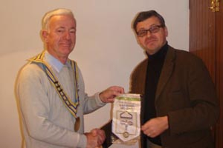  President Walter presenting our Club Flag to  Rtn Volcke Marg from Belgium
Few Recently received Flags from around the world
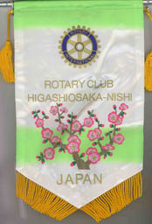 |  |  | 

THE ROTARY INTERNATIONAL ► NEWS
2008 RI Convention in Los Angeles
When thousands of Rotarians gather in Los Angeles for fun and fellowship at the 2008 RI Convention, they will also have the opportunity to hear inspirational keynote addresses from two prominent speakers with a global view.
Dr. Margaret Chan, the director-general of the World Health Organization (WHO), will give the keynote address at the third plenary session on Tuesday, 17 June, a day themed “Rotary Today.” 2008 marks the twentieth year of the historic global partnership of Rotary International with WHO, the United Nations Children’s Fund (UNICEF), and the U.S. Centers for Disease Control (CDC) to eradicate polio. Chan, who began her post in November 2006, has been a key ally in the initiative. In November, she praised the US$100 million grant from the Bill & Melinda Gates Foundation to The Rotary Foundation as an “investment [that helps] us reach the finish line and is precisely the catalyst we need to get additional resources to finish polio.” Learn more about Chan.
Stephen Lewis, the former special envoy to UN Secretary-General Kofi Annan and current chair of the Stephen Lewis Foundation in Canada, will be the keynote speaker on the morning of Wednesday, 18 June. His organization works to support communities affected by HIV/AIDS in Africa at the grassroots level, providing care to dying mothers and surviving grandmothers, and assisting AIDS orphans. Lewis is also co-director of AIDS-Free World, a U.S.-based advocacy organization.
These star humanitarian speakers, as well as featured entertainer singer Natalie Cole, will ensure that the 2008 RI Convention will be an unforgettable event. Be sure to register by 15 December to save on registration fees.

Editor: Rabi Karmacharya, Club Service Director email: rabikarma@gmail.com

----- Original Message -----
From: "Rabi Karmacharya" <rabikarma@gmail.com>
To: "Rabi Karmacharya" <rabikarma@gmail.com>
Sent: 3 January, 2008 15:40
Subject: BC Vol 16 07-08

Here is the latest edition of our Breakfast Chatter. Enjoy.
-Rabi
Club Service Director 2007-08
RC KTM Mid-Town

